# Research about BLS around infants

The guidelines for BLS for kids are just a little bit different then BLS for adults the difference can mostly be found in the technics of BLS for children. For children there are 2 different age groups which are 0-1 year old’s and 1 – till about 16 years old. In this report I’ll be looking at what makes BLS around 0-1 year old’s different than BLS for everyone else.

The biggest cause of cardiac arrests at children come from hypoxia, while a cardiac arrest for an adult is mostly caused by an primary cardial issue.

For BLS the most important thing for children is getting oxygen back in the system. BLS can be performed using the just basic technics without extra tools by just one trained nurse.

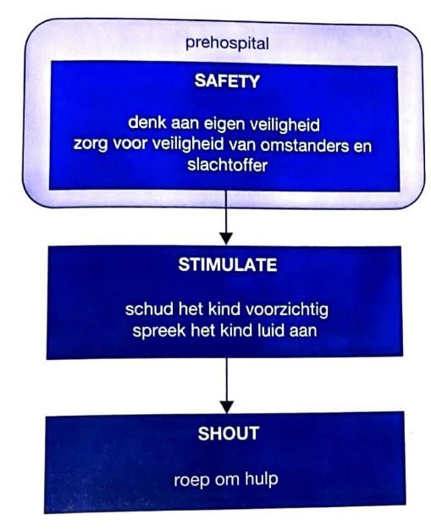This is a diagram in dutch about the steps of how to approach the situation when BLS is needed.

1. Safety, think about your own, bystanders and the victims safety first.
2. Stimulation, shake/move the child carefully and speak loud to the child.
3. Shout for help

When performing BLS on infants it’s key to start with CPR and thorax compressions. These compressions should be around 4cm deep for most infants.

The main differences between BLS for 0-1 year old’s and 1 – till about 16 years old’s. Have been documented in a diagram that you can see below.

Book: advanced paediatric life support

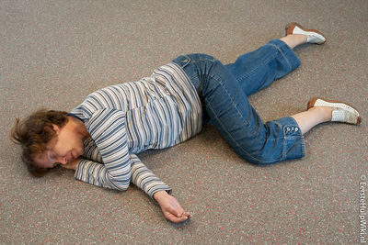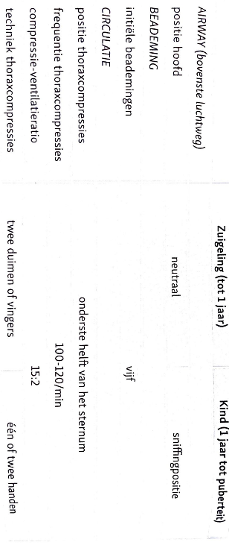

If an infant is unconscious it’s important that you put the child in a stable lateral position which is shown in the picture to the right.

Source: https://www.eerstehulpwiki.nl/wiki/index.php/Stabiele_zijligging

Here’s a video of how to perform BLS on an infant: { <https://nhcps.com/lesson/pals-bls-infants-0-12-months-old/> }